A Data Science Approach to Forecast Energy Consumption in Australia
Abdul El-Hamawi¹[z5019165], Chris Strods¹[z5329477], David Anderson¹[z5343521], Jamie Twiss¹[z5353394], Shubhankar Dutta¹[z5304573] and Sonal Chawla¹[z5092985]
¹ University of New South Wales, Sydney NSW 2052, Australia
Abstract. Electricity prices are highly sensitive to the available production and transmission capabilities. The ability to forecast energy demand is essential to ensure the stability of Australia’s electricity grid, and therefore support the Australian economy. In the past, demand forecasting has been done through a combination of econometric (top down) and end-use (bottom-up) modelling approaches, as well as operator intuition. Recent advances in computing and technology have made it possible to integrate more sophisticated approaches using Artificial Intelligence (AI), particularly Neural Networks and Machine Learning which can improve the accuracy of existing models. Building on research already conducted on the use of these techniques in forecasting, this project will aim to create a new demand forecasting model, using past weather data (temperature) and past demand as inputs. The model will be benchmarked against an existing demand forecast dataset.
Keywords: Demand Forecasting, Neural Networks, Machine Learning.
- Introduction
1.1 Introduction

Energy is increasingly becoming a vital input for the economic and social development of any economy. Accurate forecasts of energy demand are important not only for price stability, but also aid policy makers, and other decision makers, in planning supply system operations. Outages or price spikes can have a sharp negative economic effect, as seen in the 1973 oil crisis [1] when oil prices surged 300% in 5 months.
Given the importance of accurate forecasts, a huge number of studies on forecasting methods have been conducted since early 1970s. However, forecasting energy usage has proven to be challenging; long-term forecasts in the United States were more than twice the actual rates due to underestimating uncertainties in input data [2]. Recently. forecasting models that provide a single valued output for forecasted energy demand have come under criticism due to their inherent inaccuracy, resulting from the chaotic nature of most standard model inputs, such as temperature and weather data [3]. Artificial Intelligence (AI) energy forecasting models have started to gain popularity because of their ability to process time series data and capability to deal with noise data. Probabilistic Load Forecasting (PLF) is an approach that provides a range of different forecasts with their prescribed probabilities, and has been accepted as providing greater utility than a single point forecast model.
This report aims to create an accurate energy demand forecasting model based on AI techniques. In particular, the report will highlight two techniques – machine learning and neural networks. We will be looking at past electricity demand data and past weather data from New South Wales as potential inputs of the model. A more concentrated dataset like the one in this report will enable us to determine the appropriate modelling technique without having to take other factors like location into consideration.

1.2 Intended clients and desired outputs

The predicted results from a demand forecast model are intended to benefit a number of clients. In order to identify these potential clients and their needs, we interviewed a former senior official at Australian Energy Market Operator (AEMO). Based on those findings, this report aims to target three classes of clients who might be interested in the model:

- Market operators such as AEMO—forecasts ranging from one day to one week. They will use these forecasts to anticipate and avoid mismatches between supply and demand, for example by deferring power-plant maintenance or asking a large customer to go offline.
- Generators—forecasts ranging from 0.5 to 8 hours. Coal generators can ramp up output when required, given notice of several hours; gas generators require a time frame that is generally shorter (and can be as short as 5 minutes).
- Traders—forecasts of any time frame. A number of parties trade electricity on the wholesale market, seeking to anticipate price movements. There are a variety of electricity contracts that make it possible to trade across many different time scales; the key factor is less the timescale and more the accuracy of the model, as trading is profitable only when the trader has better information than the market as a whole.
- Literature Review
As electricity demand forecasting has attracted a widespread interest from several practitioners around the globe, there is a variety of approaches including statistical and artificial intelligence (AI) being used, including:
- Time series methods [4] which implement autoregressive integrated moving average with exogenous variables (ARIMAX) for energy forecasting. This is the most used time series model as it can use temperature and time of day as inputs.
- Artificial neural network (ANN) models [5] using historic data to forecast several days ahead. These models [6] create a PLF output (which is preferred) with best accuracies for one day ahead predictions.
- Machine Learning techniques work best when finding best solutions against a test criterion.
- Support vector machines (SVM) [7] which have been used in short-term forecasting and can achieve superior results to an autoregressive method.
Additionally, the Monte Carlo method has proven to be useful in pre-processing weather data to reduce its chaotic behaviour. The resulting model usually has higher forecasting accuracy [8].
Simple models also exist such as modelling energy demand in relation to consumer income [9], and have been shown to be similarly accurate as more complex contemporaneous models [10]. A PLF forecasting model that uses an ensemble of older, simpler models along with newer machine learning models perform well in short-term demand forecasting.
In order to understand how the modelling accuracy varies across different methods, the approach will be to carry out two modelling methods on the same dataset after pre-processing – Machine Learning and Neural Networks. Moreover, our model will feature a PLF output rather than a single point, aiming at achieving the lowest possible discrepancy between predicted and actual energy usage (highest accuracy) as the ideal measure of model success - replicating the measures used in the previously reviewed analyses.
- Material and Methods
  - Software
The primary software used for data pre-processing and data analysis will be Python as it offers a wide range of libraries to carry out different modelling techniques. In particular, the Python libraries used are:
- List of libraries used and their purpose
- X
- X
- X
Moreover, for the purpose of creating effective visualisations we have relied on XXX because XXX.
  - Description of Data and Pre-processing
To achieve our goal of developing an effective energy demand forecasting model, we will be analysing past temperature and energy usage data in New South Wales. A larger dataset was available which contained information on four Australian states (NSW, VIC, QLD and SA), however we decided to concentrate on just one state (NSW) for the purpose of avoiding complexities due to large datasets and different locations. The data was forked from the main GitHub repository provided and contained csv files with information on temperature, forecast demand, and actual demand. The forecast demand data files are the largest, containing multiple energy usage predictions for each DATETIME object.
The three datasets for NSW contain data from January 2010 to March 2021. In order to create a more relevant and meaningful dataset for data modelling, the team decided to exclude the first two years. Data from 2010 and 2011 did not show any additional information that was not represented in the more recent years. We also decided to keep data from 2020 and 2021 as it includes the change in demand due to COVID, representing a new normal in the way people and businesses will function.

The electricity demand and temperature datasets are merged to create the main dataset to begin modelling. The following difficulties were encountered in data preparation, along with their resolutions/fixes:
- The electricity demand dataset had data for every 30 minutes, while temperature data is more erratic with inconsistent DATETIME. We used a left join to merge the datasets which populated the demand DATETIME with temperature data.
- X
- X
The forecast demand data for NSW will be used as a benchmark for the two models created, instead of an input. This is to ensure that the model we produce works at par, or better than the forecasting models that exist in the market today. Moreover, relying on a pre-existing forecast may interrupt the effectiveness of the modelling method.

  - Assumptions
The following assumptions were made during the data preparation, data modelling and reporting stages of the project:
- While we have checked for outliers or obvious errors, we have otherwise assumed that the provided data is correct.
- Temperature measured at a single point in Bankstown is predictive of demand for the entire NSW region.
- During the merging of datasets, any missing values were XXX.
- The forecasting methods used to create the forecast demand dataset is unknown. We will assume that it is a suitable method for the data in order to use it as an evaluation criteria for our models.
- X

  - Modelling Methods
The team trialled several different approaches in order to identify the most promising model(s) to build. The criteria we evaluated the different approaches on were:

- Predictive power. Based on what we know about different model types, and some preliminary modeling attempts, which approach(es) do we think are most likely to lead to effective models for delivering commercial outcomes (as defined in 1.2 above)?
- Suitability for the problem. Given that the project is a windowed time-series analysis, some approaches may not be feasible or realistic, such as XXX
- Familiarity. Given the tight time constraints, we prioritized modeling approaches that the team was already familiar with, such as those taught in Machine Learning and in Neural Networks.
- Others???

While we experimented with other approaches, such as fitting splines to the data and XXX, we ended up deciding to build two separate models, a Neural Network (NN) model and a Machine Learning (ML) model. We decided that two models would enable us to compare the accuracy of one with the other, and would also make our approach more resilient in case one or the other model either couldn’t be made to work or wouldn’t have sufficient predictive power to be useful. In a commercial context, we agreed that to manage our risk, we would prefer to have a backup in case one model wasn’t ready or sufficient when the client expected to see the results.

We agreed that we would use XXX as our loss function consistently across all models, in order to ensure that we were comparing them consistently.
    - Neural network

We divided the modelling team into two sub-teams, the first of which set out to build a neural network. The team took a structured approach to experimenting with different architectures, building a model that could easily be configured along the following dimensions:
- Overall architecture—four options were tested, with either an LSTM or GRU network, and then either 1 or 2 fully-connected linear layers
- SGD or Adam optimisers
- Output-size variables for the output of the LSTM/GRU network and then each of the linear layers
- Learning rate
- Weight decay (Adam only)
- Batch size
- Epochs

Through systematic experimentation, the team found the best performance on the test sample with the LSTM network plus one linear layer and the Adam optimiser. This architecture, plus the configurations of the other variables:
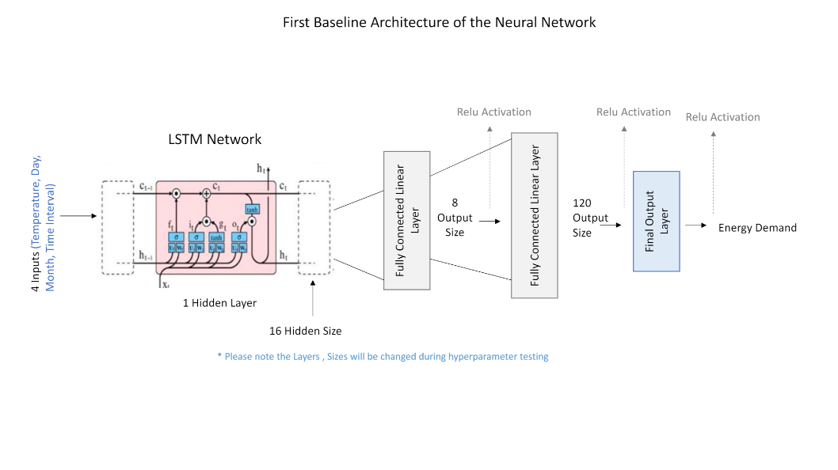
In the end, this proved to be our most accurate model, with a loss of XXX. The results of both models are discussed in more detail in section 5 below.

    - Machine learning

The second team...

- Exploratory Data Analysis (EDA)
The purpose of data exploration is two-fold: first, it enabled the team to understand the data at a high level, including the variability in both the target and input variables. Second, it serves as a first step towards feature selection, identifying how the shape of the target variable changes under different values for each of the input variables.

As a first step, the team began reviewing the data for completeness and consistency. As noted above, the data was very clean overall, with relatively few anomalies. Some file names were misspelled, and some files had index columns and some did not, but there was little or no garbled or missing data.

The team then produced a series of visualisations of the data. As noted above, the purpose of this was to understand the overall variability of the data, and then the importance of various attributes. This, in turn, was a critical step for feature selection.

As the two main variables we had were temperature and time (leaving aside the forecast data, which as discussed in 3.2 above, we will not use to build our model), we looked at scatterplots and boxplots linking actual demand to those variables. With time, we expected that we might see cyclicality of demand across individual days, weeks, and years, and so looked at different aspects of time.

The first check was to see the correlation between temperature and demand. As expected, from the project brief, this showed that demand is highest when temperature is both very low (for heating) and very high (for cooling):

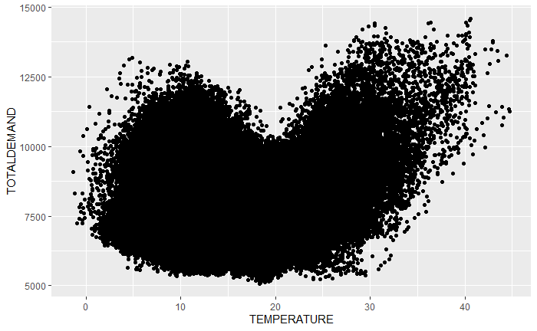
We also then looked at demand across different time scales. We started at the smallest possible scale, demand across time within a single day:

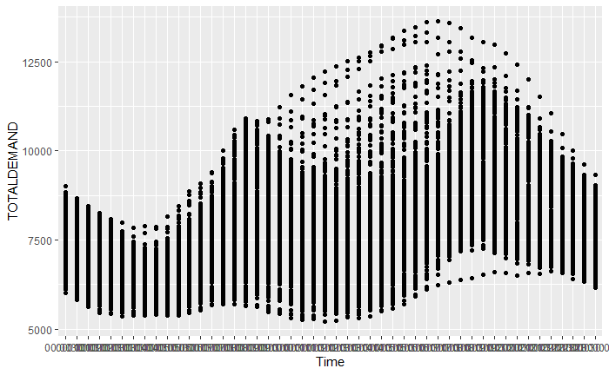
As we can see here, demand is lowest overnight, building up to a first peak in the morning, then dipping slightly before building to a second peak in the evening, and then falling again.

We then zoomed back to days of the week. This showed relatively consistent demand on weekdays, but lower demand on weekends:

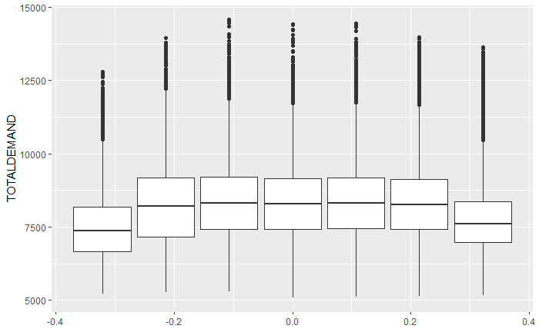

We then looked at demand over the course of the year. We did this both by month and by week; we found that looking by week gave us a sharper view of seasonal trends. As would be expected given the correlation between temperature and demand shown above, demand was highest in the summer, followed by the winter, with spring and fall noticeably lower. Interestingly, winter months had the most volatile demand peaks.

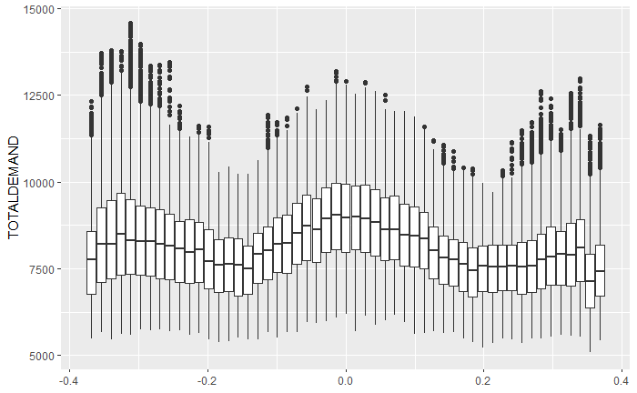
Finally, we looked at trends by year:

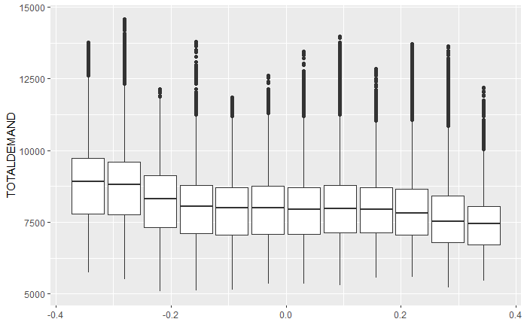

This showed a secular decline in demand over 2010-12, a long flat period from 2012 to 2019, and then lower demand again in 2021 and 2021.

The importance of all of this is that it will help us understand what features are important to include in our models as well as what data to use. Based on these charts, the group agreed that temperature, time of day, time of year, and day of week (encoded as 0 for weekend, 1 for weekday) should all be features.

- Analysis of Results
Text

- Discussion, Conclusion, and Further Issues
Text

- Example Template
  - A Subsection Sample
Please note that the first paragraph of a section or subsection is not indented. The first paragraphs that follows a table, figure, equation etc. does not have an indent, either.
Subsequent paragraphs, however, are indented.

Sample Heading (Third Level). Only two levels of headings should be numbered. Lower level headings remain unnumbered; they are formatted as run-in headings.

Sample Heading (Forth Level). The contribution should contain no more than four levels of headings. The following Table 1 gives a summary of all heading levels.
Table 1. Table captions should be placed above the tables.
Heading level | Example | Font size and style
Title (centered) | Lecture Notes | 14 point, bold
1st-level heading | 1 Introduction | 12 point, bold
2nd-level heading | 2.1 Printing Area | 10 point, bold
3rd-level heading | Run-in Heading in Bold. Text follows | 10 point, bold
4th-level heading | Lowest Level Heading. Text follows | 10 point, italic
Displayed equations are centered and set on a separate line.
x + y = z (1)
Please try to avoid rasterized images for line-art diagrams and schemas. Whenever possible, use vector graphics instead (see Fig. 1).

Fig. 1. A figure caption is always placed below the illustration. Short captions are centered, while long ones are justified. The macro button chooses the correct format automatically.
For citations of references, we prefer the use of square brackets and consecutive numbers. Citations using labels or the author/year convention are also acceptable. The following bibliography provides a sample reference list with entries for journal articles [1], an LNCS chapter [2], a book [3], proceedings without editors [4], as well as a URL [5].

References
- Author, F.: Article title. Journal 2(5), 99–110 (2016).
- Author, F., Author, S.: Title of a proceedings paper. In: Editor, F., Editor, S. (eds.) CONFERENCE 2016, LNCS, vol. 9999, pp. 1–13. Springer, Heidelberg (2016).
- Author, F., Author, S., Author, T.: Book title. 2nd edn. Publisher, Location (1999).
- Author, F.: Contribution title. In: 9th International Proceedings on Proceedings, pp. 1–2. Publisher, Location (2010).
- LNCS Homepage, http://www.springer.com/lncs, last accessed 2016/11/21.

References
- Kettell, S., 2020. oil crisis, Chicago: Encyclopedia Britannica.
- Craig, P., Gadgil, A. & Koomey, J., 2002. What Can History Teach Us? A Retrospective Examination of Long-Term Energy Forecasts for the United States. Annual Review of Energy and the Environment, pp. 83-118.
- Hong, T. & Fan, S., 2016. Probabilistic electric load forecasting: A tutorial review. International Journal of Forecasting, pp. 914-938.
- McDonald, J. & Fan, Y., 1994. A Real-Time Implementation. IEEE Transactions on Power Systems, pp. 988-994.
- Bakirtzis, A. G., Petridis, V. & Kiartzis, S. J., 1996. A Neural Network Short-Term Load Forecasting. IEEE Transactions on Power, pp. 858-863.
- Xu, L., Wang, S. & Tang, R., 2019. Probabilistic load forecasting for buildings considering weather forecasting uncertainty and uncertain peak load. Applied Energy, pp. 180-195.
- Mohandes, M., 2002. Support Vector Machines for Short-Term Electrical Load Forecasting. International Journal of Energy Research, pp. 335-345.
- Zhao, J., Duan, Y. & Liu, X., 2018. Uncertainty Analysis of Weather Forecast Data for Cooling Load Forecasting Based on the Monte Carlo Method. Energies, pp. 190-199.
- Codoni, R., Park, H. & Ramani, K., 1985. Integrated Energy Planning: A Manual. Kuala Lumpar: Asian and Pacific Development Center.
- ​Armstrong, S., 2001. Principles of Forecasting. Boston, MA: Springer.

